**77879799**

Agreement url:   
http://www.mtxb.com.cn/archive_list.htm

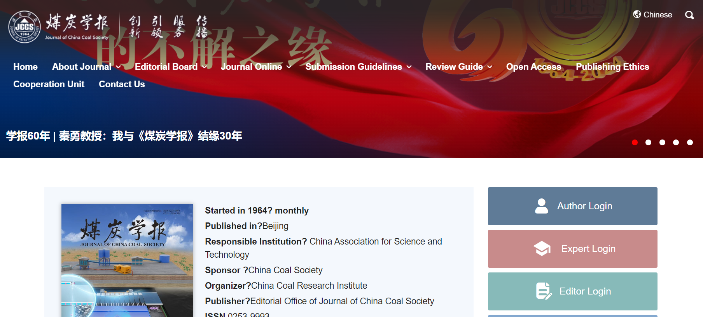

Select English Version

Current issue

Publication Month

Publication year

Download the pdf

Page range

DOI

English title

* **In here both English and Chinese toc needs to be captured.**